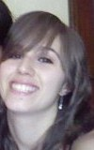
My name is Valentina Leviti. I’m seventeen and I’m a student. I’m from Vercelli and I go to linguistic high school.
I live in a flat with my family. My mother is Daniela and my father is Cesare. My mother works in a big firm and my father works in Cerruti. I have a sister, she is Silvia and is twenty-nine. She lives in Torino with her husband and son.
My hobbies are dancing, going out with my friends, doing shopping and listening to music. I like football and volleyball. I like eating all, except
anchovies.

