Hallo everyone,

my name is Francesco and I live in a pretty small town near Vercelli, our zone is completely surrounded by rice fields and when summer comes, mozies suck your blood like crazy!
I’m an 18years old guy that loves to practice sport, golf and ski most of all, but I also love to ride my motorbike.

When I have some free time I usually go and play golf if it’s afternoon, you have to practice a lot to improve your play, but certainly we are a group of friends that sometimes do everything but play golf…
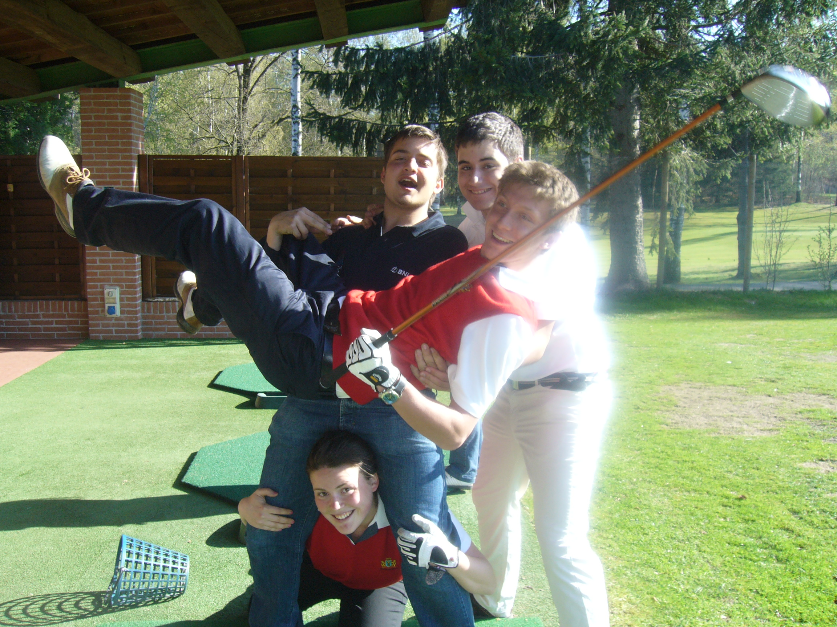

And if I can’t play golf I get out with friends, we are pretty used to go to disco on Saturday night, and that’s really fun!!! During the school time is difficult to get out in the week because of the huge amount of work that is given to us by our teachers, we study like crazy! But it’s nothing that kills us.
What can I say about me? Well…I have two brothers, one has just get married on the 14th of June and he’s 34,and the other one is 31, I still live with my parents and my lazy black cat, next year is my last year of high school, then I have to choose a university, but I don’t have an idea!

